Setting up your Primary account for a Local SQL Database Service

1. Log into SSMS with your Dash account
2. Go to the security folder in the object explorer
   1. 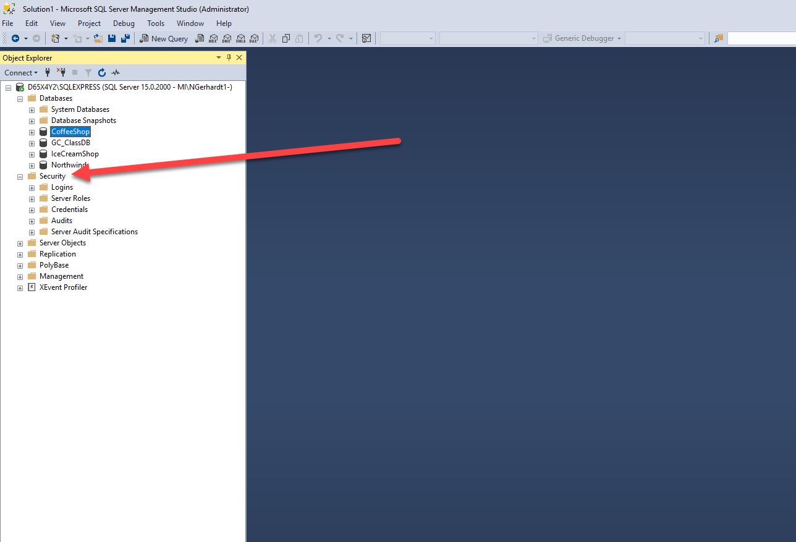
3. Right click on **security** and select new > Login…
   1. 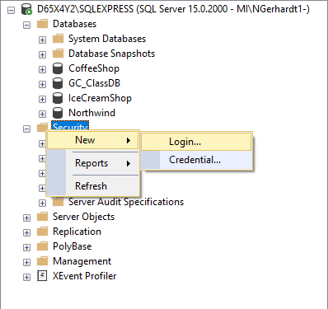
4. Enter in the Username with domain.
   1. example: mine is “**MI\Ngerhardt1**”
   2. 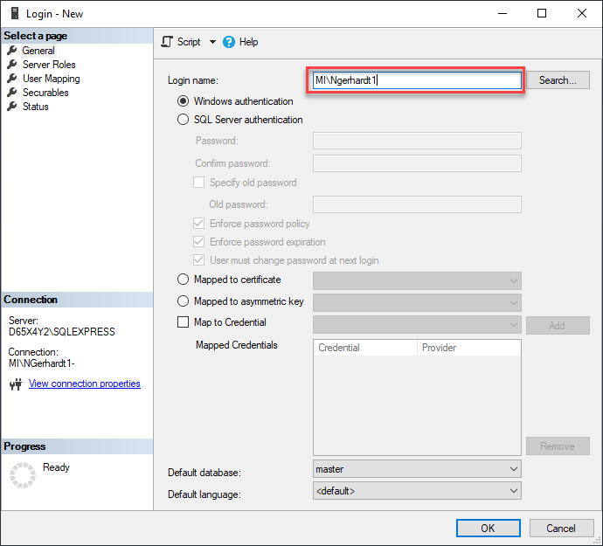
   3. Under **Server Roles**, grant your Primary Sysadmin and public access to your SQL database (for when you are connected)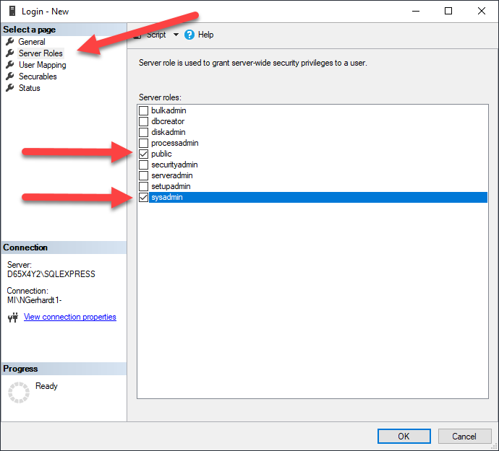
5. Under **User Mapping** check each database you want to grant access to
   1. (Warning: do **not** check master, model, msdb or tempdb)
   2. 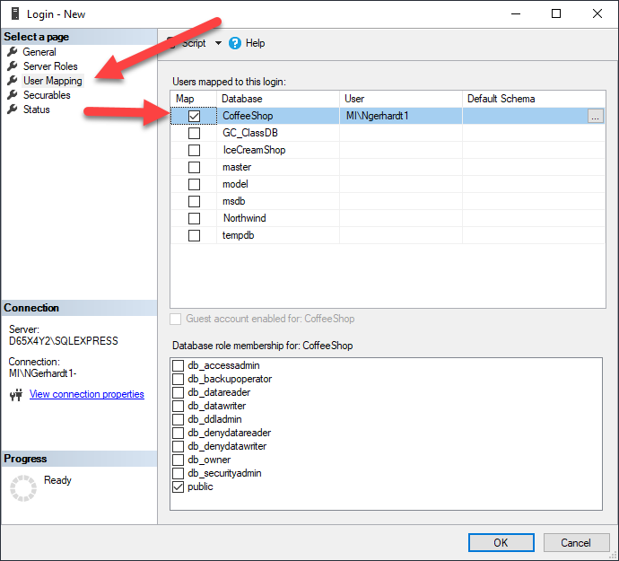
6. Make sure the **Default Schema** is dbo, and you are set as a db_owner and public for each database
   1. 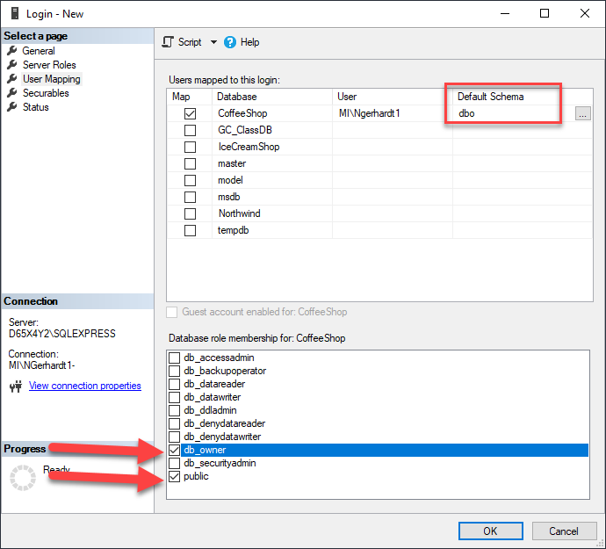
7. Lastly under **Securables**, you need to give yourself access to connect to the database
   1. 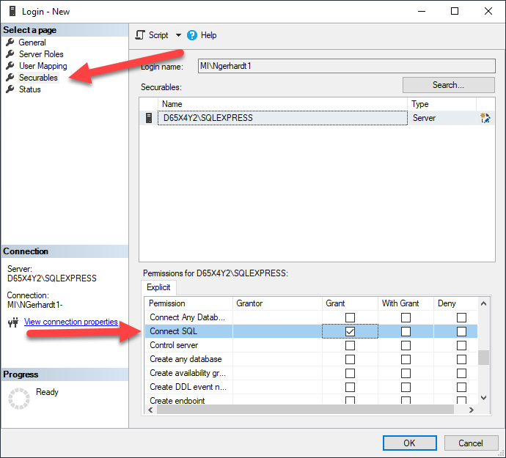
8. Click ok and test
   1. You can double check your access against your dash account in the Security > Login’s folder